2APHY Nuclear Physics Assignment One 2009 Due: Monday 18th May

Name: _________________________________________________ (50 marks total)
- Complete the following. (3 marks)
Element | Nuclide | Atomic Number | Number Of Neutrons | Mass Number
Nitrogen-14
 | $${}_{7}^{\text{13}}{}N$$ | 7
 |  | 6 |  | 14
Helium-4

- Two of the elements above are isotopes of each other. Which are they and why are they isotopes?
_______________________________________________________________________________
_______________________________________________________________________________
_______________________________________________________________________________
______________________________________________________________________ (2 marks)
- In a lab report on a Nuclear Physics experiment, a student summarized some information on radiation. The table below shows part of his report. Complete the table to include all the information. (3 marks)

What it is | Radiation symbol | Name of radiation | Transmutation ability (yes or no) | Stopped by
Like a Helium nucleus
High speed electron
Electromagnetic radiation

- Complete the following equations and name the radiation or particle produced.
a. ${}_{\text{92}}^{\text{238}}{}U$ → ${}_{\text{90}}^{\text{234}}{}\text{Th}$ + ________________________ (1 mark)
b. ${}_{6}^{\text{11}}{}C$ → ${}_{5}^{\text{11}}{}B$ + ________________________ (1 mark)
c. ${}_{\text{12}}^{\text{24m}}{}\text{Mg}$→ ${}_{\text{12}}^{\text{24}}{}\text{Mg}$ + ________________________ (1 mark)
d. Calcium-45 decays emitting a beta particle and a new element is formed. (3 marks)
  - Write the full nuclear equation.
_______________________________________________________________________
  - What is the atomic number of the new element? _____________
  - What is the mass number of the new element? ____________

- Explain, using your understanding of the structure of alpha, beta and gamma radiation, why alpha particles can’t penetrate the skin, beta can penetrate to about 2.0 cm and gamma can go straight through the body. (3 marks)

______________________________________________________________________________________________________________________________________________________________________________________________________________________________________________________________________________________________________________________________________________________________________________________________________________________________________________________________________________________________________________________________________________________________________________________________________________________________________________________________________________________________________________________________________________________________________________________________________________________________________________________________________________________________________________________________________________________________________________________________________________________________________________________________________________________________________________________________________________________________________________________________________________________________________________________________________________
- People who work in mines, especially those that may contain small amounts of radon gas, are strongly advised not to smoke as well as this increases their chance of getting cancer. Explain why breathing in radon gas (which is an alpha emitter) can cause cancer. (2 marks)

__________________________________________________________________________________________________________________________________________________________________________________________________________________________________________________________________________________________________________________________________________________________________________________________________________________________________________________________________________________________________________________________________________________________________________________________________________________________________________________________________________________________________________________________________________________________________
- Within a Nuclear Power Plant, some research scientists were studying the half-life of Polonium. The activity of a particular sample of polonium was 8.4 x 10³ Bq. They knew that the half-life of polonium was 140 days and wanted to know how long it would take for the sample to reach an activity of 525 Bq. Using your understanding of half-life, calculate this time for them. (2 marks)

- University students, studying the activity of a particular radioactive isotope which had a half-life of 12.0 hours. If the original activity of the sample was 448 kBq, what would the activity be 3.00 days later? (2 marks)

- An industrial worker accidentally inhaled a radioisotope with an activity of 0.200 kBq. The substance swallowed has a very long effective half-life and therefore the activity will not change significantly during the worker’s lifetime. Every decay of the isotope releases 1.12 x 10⁻¹⁴ J of energy into the body and the radioisotope is not eliminated from the body. Determine the amount of energy absorbed in one year by the worker from this substance. (1 year = 365 days) (2 marks)

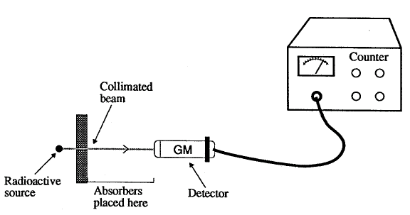
- Students were given a radioactive source which emitted either alpha, beta or gamma radiation. They were instructed to identify the types of radiation emitted by the source. The experimental arrangement is illustrated.

Their results were:
Material between source and counter | Counts per minute
10 mm air | 3549
Sheet of paper | 2613
2 mm of aluminium | 156
5 cm lead | 8

What type of radiation was emitted from the source? _______________________ (1 mark)

- Some radioisotopes have a short half life such as Sodium-24 (Na-24) which has a half-life of 15 hours. Sodium-24 is a beta emitter with a high activity and is used as a tracer in blood circulation studies.
- Write the nuclear equation for sodium-24 emitting beta radiation. (1 mark)
_______________________________________________________________________________
- A medical technician received a 5.0 g sample of sodium-24 but a week later she needed to order a new sample even though the original sample still had a mass of 5.0 g. Explain why. (1 marks)

___________________________________________________________________________________________________________________________________________________________________________________________________________________________________________________________________________________________________________________________________________________________________________________________________________
- In an experiment, a student collected the following data for the decay of a radioactive isotope. On the graph paper below, plot the graph the student would have correctly plotted and from the graph estimate the half-live of the radioactive isotope:

Count rate (per second)
1005 820 670 555 455 370 300
Time (minutes)
0 1 2 3 4 5 6

Half-life of radio-active isotope

Half-life = __________________ (2 marks)

